ExpressJS

* First create a normal empty folder in explorer
* Then type npm init -y
* Then npm install express



“npm install nodemon” for auto-refresh

(Or) use node filename.js

Rules

* Express JS is not to be used to create UI
* Never use browser to test the backend use swagger or other APIs

Testing using API clients

* Use any extension in vs code
* Type the icon on the left bar
* Then click new request
* Give path then use

For cmd testing,

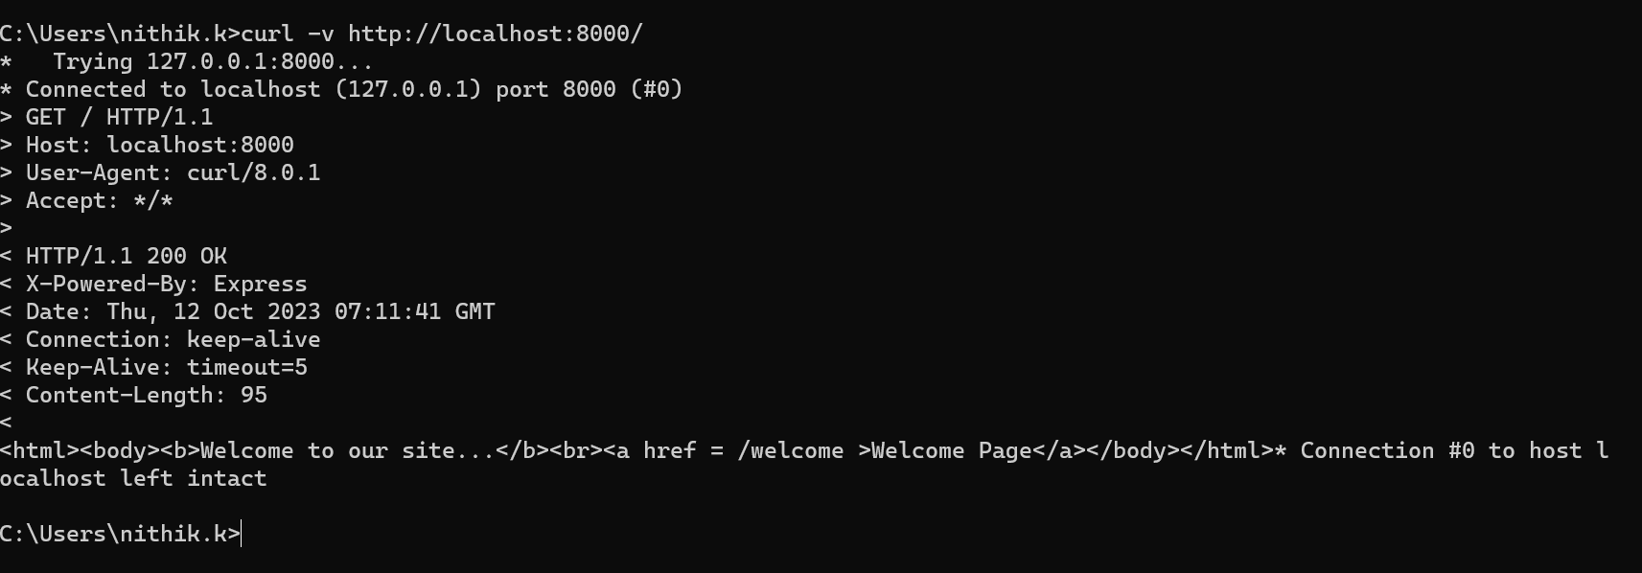

Express JS

* Has built in controller so just need models.

For post request,

